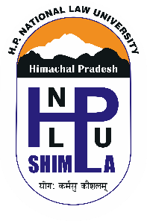
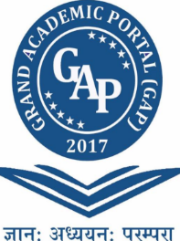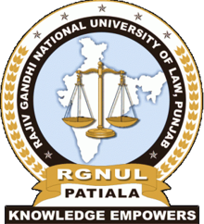
Himachal Pradesh National Law University, Shimla
Jointly with
Grand Academic Portal, Gujarat

Cordially invites you to the
International Conference
on
“Human Rights, Democracy and Human Dignity: 70 Years of Universal Declaration on Human Rights”
in association with
Rajiv Gandhi National University of Law, Patiala &
University of Hindu, Indonesia

November 9-10, 2019
Inaugural Function
Venue: Conference Hall, HPNLU, Shimla
Lighting the Lamp (Sarasvati Vandana) | 10.30 to 10.35am
Floral Welcome to Guests | 10.35 to 10.40am
Welcome Address  Prof. (Dr.) Nishtha Jaswal  Vice Chancellor, HPNLU | 10.40 to 10.50am
Introduction of the International Conference  Dr. Gurudatta Japee  Chairman GAP, Gujarat | 10.50 to 11.00am
Key Note Address  Prof. (Dr.) Ranbir Singh  Vice Chancellor, National Law University, Delhi | 11.00 to 11.10am
Address  Prof. (Dr.) Phil. I Ketut Ardhana  Vice Chancellor, UNHI, Bali, Indonesia | 11.10 to 11.30am
Address  Hon’ble Mr Justice L. Narayana Swamy  Chief Justice Himachal Pradesh High Court | 11.30 to 11.55am
Release of E Souvenir | 11.55 to 12.00pm
Address  Hon’ble Justice V. Ramasubramnian  Judge Supreme Court of India | 12.00 to 2.30pm
Vote of Thanks  Prof. (Dr.) Paramjit S Jaswal  Vice chancellor, RGNUL, Punjab | 12.30 to 12.35pm
National Anthem

Valedictory Function

Programme Schedule: (Nov. 10, 2019)
Venue: Conference Hall, HPNLU, Shimla
Welcome Address  Prof. Paramjit S. Jaswal  Vice Chancellor, RGNUL, Patiala | 12.30-12.40pm
Floral Welcome | 12.40-12.45pm
Summary of Conference  Dr. Preeti Oza  CEO, GAP, Gujarat | 12.45-12.50pm
Valedictory Address  Hon’ble Mr. Justice Peter Mohan Maithree Peiris  Former Chief Justice of Supreme Court, Sri Lanka | 12.50-1.10pm
Address by the Guest of Honour  Hon’ble Mr. Justice Dharam Chand Chaudhary  Judge, High Court of Himachal Pradesh | 1.10-1.30pm
Address of the Chief Guest  Hon’ble Mr. Justice L. Narayana Swamy  Chancellor, HPNLU; Chief Justice, H P High Court | 1.30-2.00pm
Feedback from Participants | 2.00-2.05pm
Best Paper Award | 2.05-2.07pm
Vote of Thanks  Prof. (Dr.) Nishtha Jaswal  Vice Chancellor, HPNLU, Shimla | 2.07-2.12pm
National Anthem

R.S.V.P.
Prof. S.S. Jaswal
Registrar, HPNLU

Plenary Session & Technical Sessions:

Day One (Nov. 9, 2019)

Plenary Session: 2.00 to 3:15 pm
Chief Guest
Hon’ble Mr. Justice Sureshwar Thakur
Judge, High Court of Himachal Pradesh

Technical Sessions
Technical Sessions-1: Theme: Human Rights: Here and Now (3.30 to 5.00pm)
Technical Sessions-2: Theme: Sexual Orientation, Gender Identity and Human Rights (3.30 to 5.00pm)
Technical Sessions-3: Theme: Human Trafficking and Issues in Human Rights (3.30 to 5.00pm)
Technical Sessions-4: Theme: Media and Human Rights (3.30 to 5.00pm)

Day Two (Nov. 10, 2019)
Technical Sessions-5: Theme: Children’s Rights (09.30 to 11.00am)
Technical Sessions-6: Theme: Legal Theories and Practices in Human Rights (09.30 to 11.00am)
Technical Sessions-7: Theme: Social Freedom, Peace, Justice and Human Rights (09.30 to 11.00am)
Technical Sessions-8: Theme: International Issues in Human Rights (09.30 to 11.00am)

Technical Sessions-9: Theme: Rights of the Specially Abled or Persons with Disability (11.00 to 12.30am)
Technical Sessions-10: Theme: Religion, Culture and Human Dignity (11.00 to 12.30am)
Technical Sessions-11: Theme: Protection of Human Dignity and Role of NGOs in Protecting Human Rights (11.00 to 12.30am)
Technical Sessions-12: Theme: Human Dignity and Sexual Orientation (11.00 to 12.30am)

Venue: Conference Hall, HPNLU, Shimla
(Himachal Pradesh National Law University Shimla, HPNLU, Shimla. 16 Miles,
Shimla-Mandi National Highway, Ghandal. District, Shimla, HP-171014. Ph. 0177-2779803.
Fax:0177-2779802 (M) 7832912831)

